COAL LAB 3
ARSH
BAI-3C
23K-0078
TASK 1:
INCLUDE Irvine32.inc

.data
num1 BYTE 25
num2 WORD 1000
num3 DWORD 50000

.code
main PROC
mov al, num1
mov bx, num2
mov ecx, num3

call DumpRegs
exit
main ENDP
END main

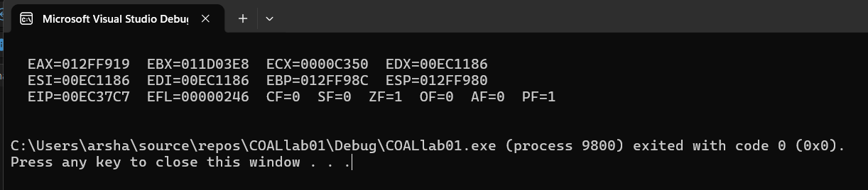

TASK 2:
INCLUDE Irvine32.inc

.code
main PROC
mov eax, 20
mov ebx, 10

add eax, ebx ; breakpoint
call DumpRegs

sub eax, 5
call DumpRegs

mov ecx, 100
sub ecx, eax
call DumpRegs

exit
main ENDP
END main

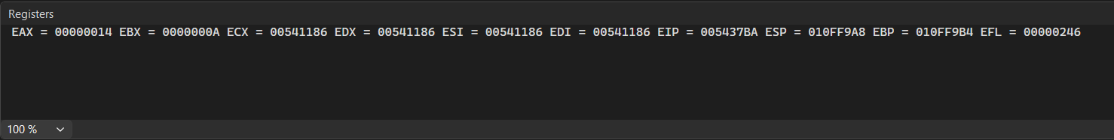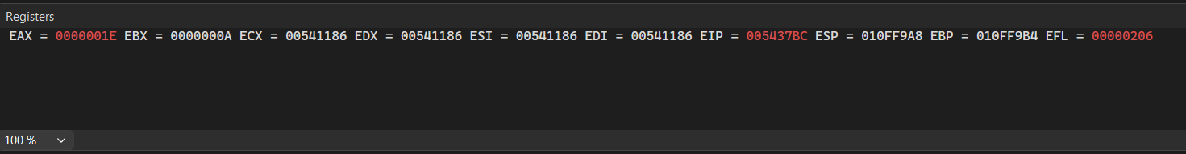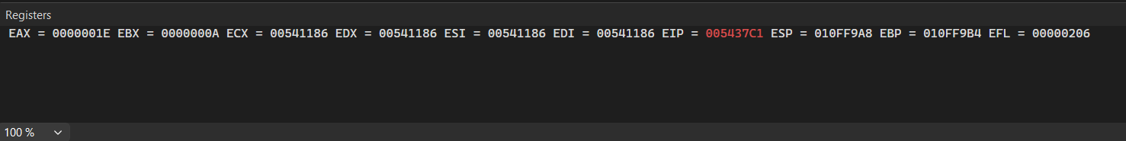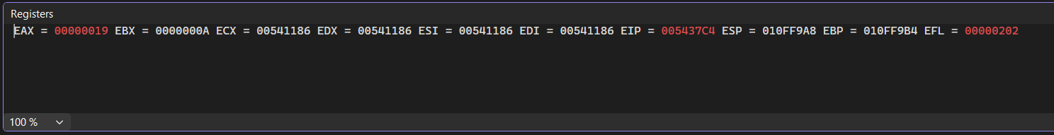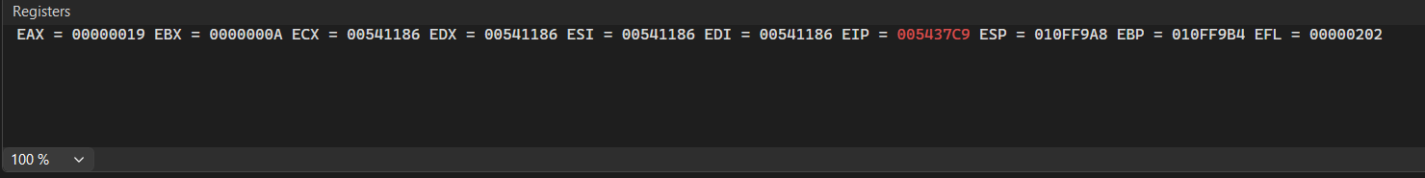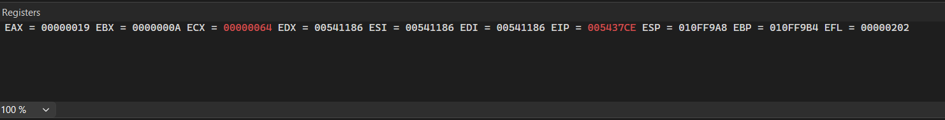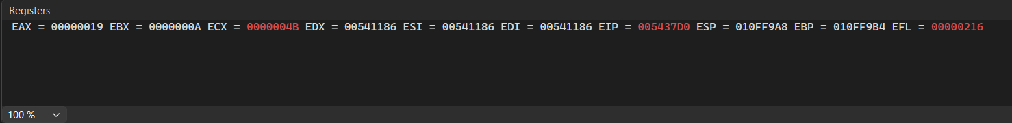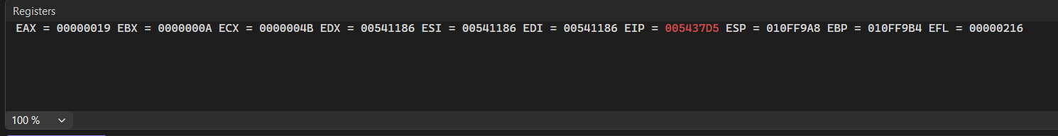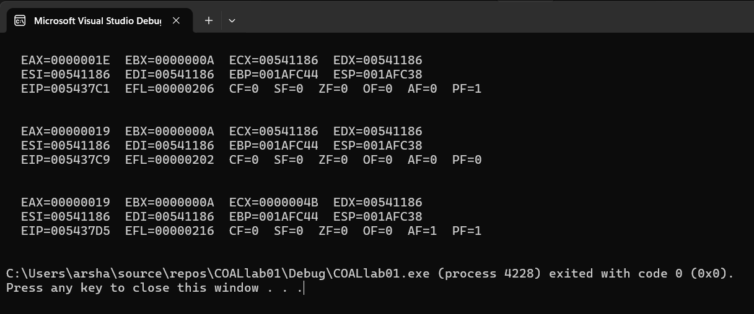

TASK 3:
INCLUDE Irvine32.inc

.data
byteArray BYTE 10 DUP(0)
values BYTE 5, 10, 15, 20, 25

.code
main PROC
mov al, values[0]
mov byteArray[0], al

mov bl, values[1]
mov byteArray[1], bl

add al, bl ; breakpoint here
sub al, 3

mov byteArray[2], al
call DumpRegs
exit
main ENDP
END main

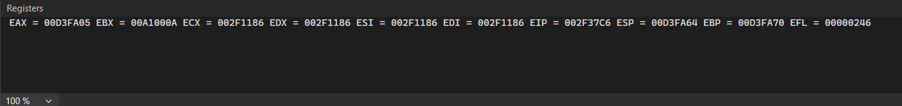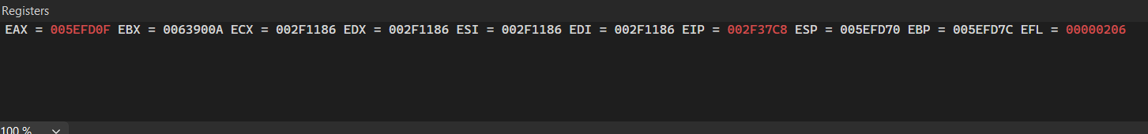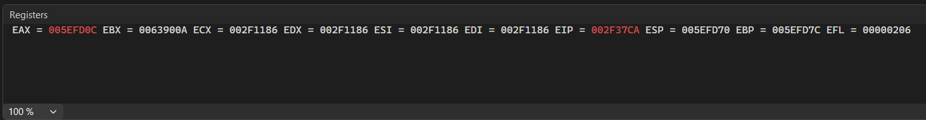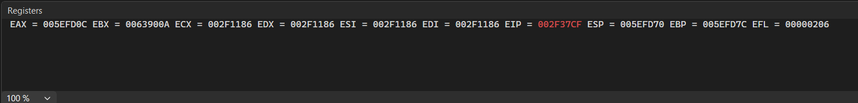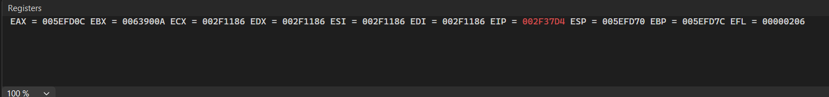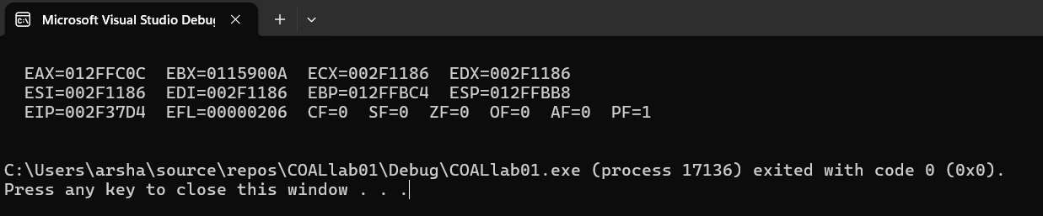

TASK 4:
INCLUDE Irvine32.inc

.data
byteVal BYTE 15
wordVal WORD 500
dwordVal DWORD 100000
byteArray BYTE 20 DUP(0)

.code
main PROC
mov al, byteVal
mov ax, wordVal
mov eax, dwordVal

mov esi, OFFSET byteArray
mov edi, OFFSET byteArray
add edi, 4

mov al, byteVal
add al, 10 ; breakpoint here
mov [esi], al

mov ax, wordVal
sub ax, 100
mov bx, ax

mov eax, dwordVal
add eax, 5000
mov [edi], eax

call DumpRegs
exit
main ENDP
END main

